1.

parent(chris, samantha).

parent(chris, sandy).

female(samantha).

female(sandy).

male(chris).

sister(X, Y) :- parent(Z, X), parent(Z,Y), female(X).

Command line: sister(X,sandy).

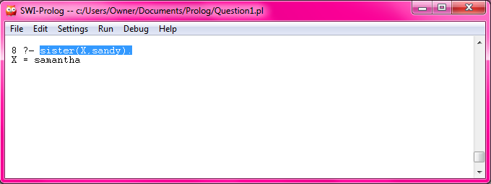

2.

maxList([M],M).

maxList([M|List],Max):- Max=M,maxList(List,Max1),M>=Max1.

maxList([M|List],Max):- Max=Max1,maxList(List,Max1),M< Max1.

Command lines: maxList([1,23,4,5],X).

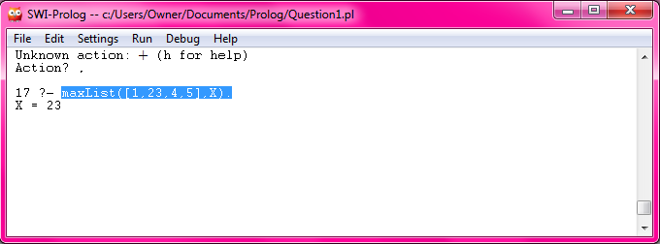

3.

inter([X|Y],I,[X|Z]) :- member(X,I), inter(Y,I,Z).

inter([X|Y],I,Z) :- \+ member(X,I), inter(Y,I,Z).

inter([],I,[]).

Command lines: inter([1,2,3],[4,5],X).

inter([1,4,5],[2,4,6,5],X).

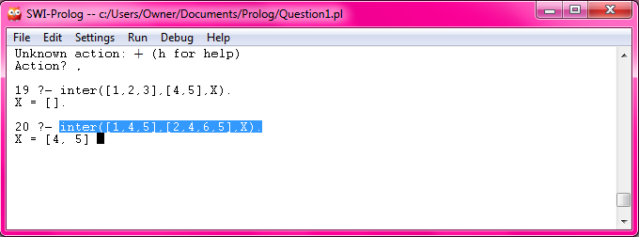

4.

union([ ], X, X).

union([X|R], Y, Z):- member(X, Y), !, union(R, Y, Z).

union([X|R], Y, [X|Z]):- union(R, Y, Z).

Command lines: union([3, 7, 1, 6], [5, 7, 2, 4, 1], X).

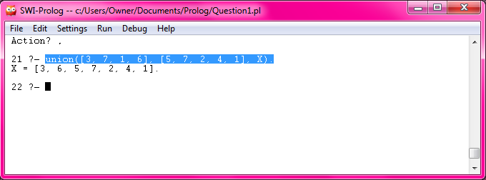

5.

quicksort([], []).

quicksort([X|Tail], Sorted) :-

split(X, Tail, Small, Big),

quicksort(Small, SortedSmall),

quicksort(Big, SortedBig),

append(SortedSmall, [X|SortedBig], Sorted).

split(X, [], [], []).

split(X, [Y|Tail], [Y|Small], Big) :-

X > Y, !, split(X, Tail, Small, Big).

split(X, [Y|Tail], Small, [Y|Big]) :- split(X, Tail, Small, Big).

Command lines: quicksort([2,6,1,5,8],X).

